Promoter Toolkit: A4 and A3 posters
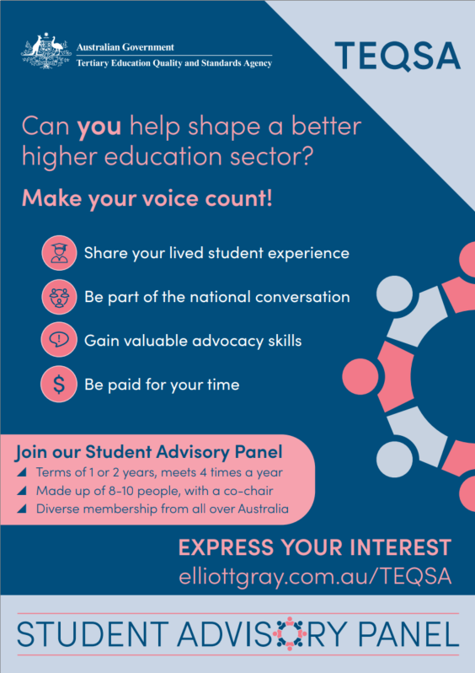

Promoter Toolkit: Social media posts
Post #1
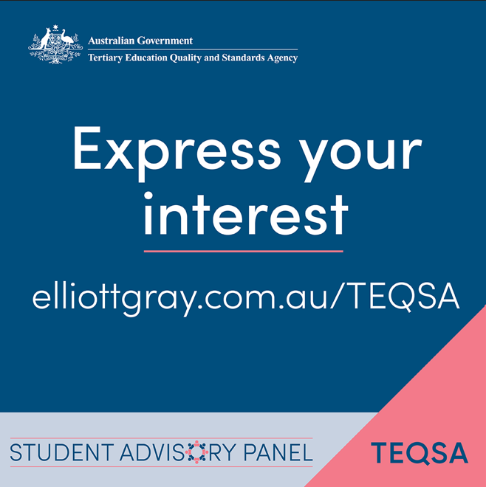
Student experience matters.
Australia’s national quality regulator for higher education is expanding the student voices they engage, beyond elected student representatives.
TEQSA is seeking expressions of interest from students for its first Student Advisory Panel. Students selected as panel members will discuss matters that affect real student experiences and be paid an honorarium.
Have your say at a national level.
Submit your expression of interest: [elliiottgray.com.au/TEQSA]
Post #2
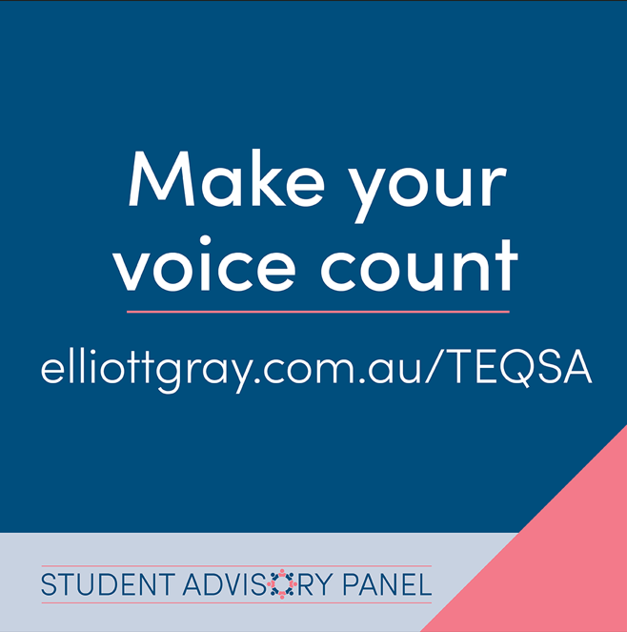
Great, good, bad or somewhere in between. Student experience counts.
Australia’s national quality regulator, TEQSA, wants students to share their lived experience in Australian higher education through its new Student Advisory Panel. Panel members will be paid an honorarium for their time. TEQSA wants to expand the student voices they engage, beyond elected student representatives.
Help shape what higher education should be.
Express your interest now: [elliiottgray.com.au/TEQSA]
Post #3
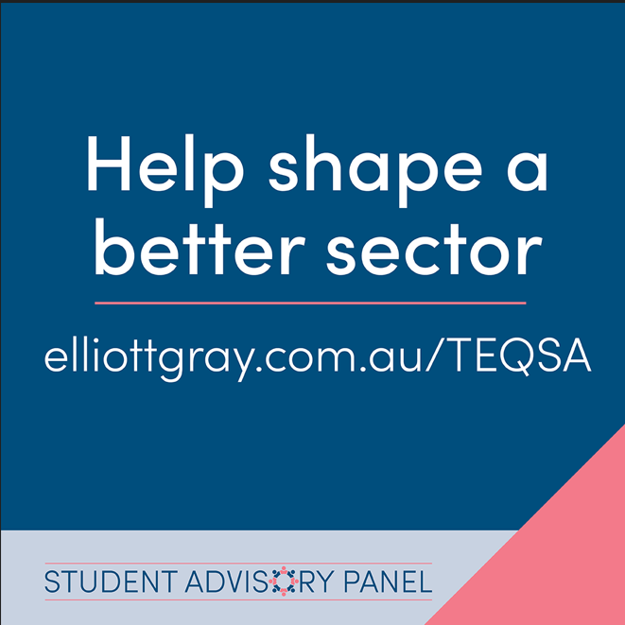
Every student experience counts. Share yours.
TEQSA is expanding the student voices they engage, beyond elected student representatives. Australia’s national higher education regulator is looking for students from every hill, beach and valley to share their lived experience through its new Student Advisory Panel. Panel members will be paid an honorarium for their time.
If you’ve got views to share, you could help shape a better higher education sector.
Express your interest: [elliiottgray.com.au/TEQSA]

Promoter Toolkit: Student talking points
- TEQSA is expanding the student voices they engage, beyond elected student representatives.
- TEQSA is establishing a Student Advisory Panel, of 8-10 students with diverse backgrounds, diverse experiences and from a range of higher education institutions across the country.
- All students, from undergraduate to post-graduate and from right across the country, are encouraged to express interest in getting involved – the only requirement is that you are currently enrolled as a student at an Australian higher education provider. Students do not need to be in student leadership positions to apply.
- Students of all backgrounds and experiences will have valuable lived experiences to share.
- TEQSA strongly encourages expressions of interest from students with diverse backgrounds, diverse experiences and from a range of higher education providers, including students who identify with one or more of these perspectives:
  - students in regional and remote areas, or who are using a University Study Hub to undertake their studies
  - Aboriginal and Torres Strait Islander students
  - international students
  - first in family students
  - students with lived experience of disability, mental health and/or neurodivergence
  - LGBTQI+ students
  - students over the age of 21 or students who have returned to study after a break of 7 years or more
  - part-time students
  - students undertaking course work or research.
- Who is TEQSA?
  - TEQSA is the higher education regulator. This national agency’s main job is to make sure students’ interests are protected, and that they attain a quality academic award with academic integrity supported by a positive student experience. Another important job TEQSA does is to watch for, and identify, any emerging risks that can impact students and the integrity and reputation of Australian higher education.
- TEQSA uses a lot of information to carry out their work, and they want to establish a Student Advisory Panel to tap into the lived experiences of real students.
- Students will be appointed to the Student Advisory Panel for a 1-year term and invited to express interest in extending their term for a second year at the conclusion of the first year.
- Students selected to be a panel member will meet 4 times a year (both online and in person), and will be paid an honorarium for their time.
- If you're interested in what happens 'on the ground' at your campus and making the quality of higher education better, express your interest in joining TEQSA's Student Advisory Panel.
- Submitting an expression of interest is easy, free and all online. Visit elliottgray.com.au/TEQSA for more details.
[ENDS]

Promoter Toolkit: Email banner and copy
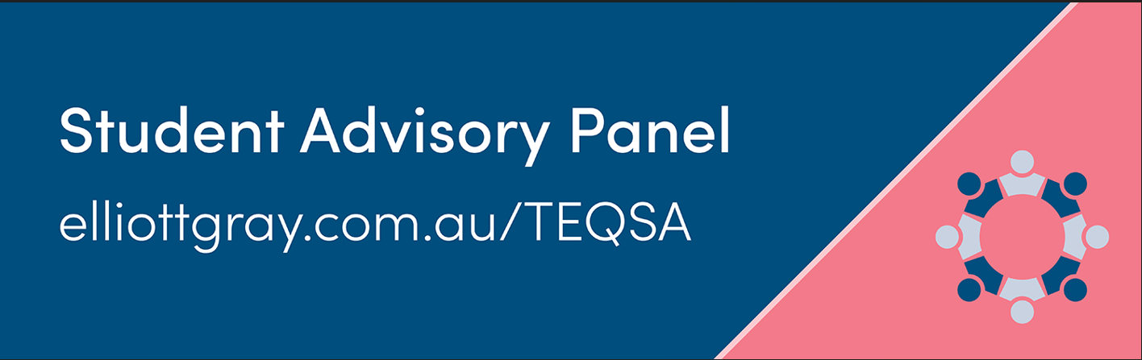
[Email to forward on to a student]
Subject line: Thought you might be interested! Student voices wanted at a national level.
TEQSA (Australia’s higher education regulator) is expanding the student voices they engage, beyond elected student representatives.
TEQSA is establishing its first Student Advisory Panel and students from right across Australia are being invited to express their interest.
This is a unique opportunity to contribute directly to national conversations about student experiences, safety and wellbeing, quality of higher education, equity and access.
Panel members will share their lived student experiences to help inform TEQSA's work across higher education and will be paid an honorarium for their time.
If you care about improving higher education, not just at your higher education institution, but across the country, this is your chance to be part of it.
Submitting and expression of interest is easy, free and all online. Visit elliottgray.com.au/TEQSA for more details.
[ENDS]

Promoter Toolkit: BLOG 1 (450 words): "What is the TEQSA Student Advisory Panel?"
- What TEQSA is in plain English
- What the panel does
- Who they're looking for
- Link to apply at the end (with a CTA)
TEQSA is Australia’s national independent regulator of higher education. All higher education providers (universities, university colleges and institutes of higher education) have to register with TEQSA to operate as a place of learning. Without a registration, a provider can’t call themselves a university (for example), offer accredited courses to students or award them a degree.
As a regulator, TEQSA operates under a framework of legislation and standards that all providers must meet. There are a few, but the main one for providers is the Higher Education Standards Framework 2021, more commonly known as the Threshold Standards. It’s like a checklist of everything a provider needs to do to run a university, a college or an institute of higher education to make it a good place to study.
TEQSA's main job is to make sure students are protected and that their degree is valued as being supported for academic integrity and quality. Another important job they do is to watch for, and identify, any risks can impact students and the integrity and reputation of Australian higher education.
They enforce the rules: TEQSA makes sure all providers meet standards (like a checklist) – things like fair assessments and good student support.
They check providers are doing a good job: TEQSA checks to make sure providers are meeting those standards. This is called assuring the quality of higher education.
They can say 'no' or step in: If a provider isn't doing things properly (that is, not meeting the Threshold Standards), TEQSA can stop them from offering courses or make them fix problems.
Students are at the heart of TEQSA’s work. The perspectives and lived experiences of students are so important to help TEQSA understand what risks are emerging across your campus and, more widely, Australia.
That’s why TEQSA is establishing a Student Advisory Panel, of 8-10 students with diverse backgrounds, diverse experiences and from a range of higher education institutions across the country. Everyone is encouraged to apply – the only requirement is that you are currently enrolled as a student at an Australian higher education provider. Students of all backgrounds and experiences will have valuable lived experiences to share.
What’s in it for you? This is a unique opportunity to gain valuable advocacy experience at a national level and meet like-minded people, while working collaboratively to uplift the quality of higher education in Australia.
If selected, you will be bringing valuable insight about what matters most to students to the table, and you’ll be paid an honorarium for sharing your experiences and insights.
If you're interested in what happens 'on the ground' at your campus, and campuses across Australia, and making the quality of higher education better for everyone, express your interest in joining TEQSA's Student Advisory Panel.
Submitting an expression of interest is easy, free and all online. Visit elliottgray.com.au/TEQSA for more details.
[ENDS]

Promoter Toolkit: BLOG 2 (450 words): "Student experience is exactly what we need"
- Why lived experience matters more than qualifications here
- Speak directly to the 8 diversity groups
- Link to apply at the end (with a CTA)
Why is it so valuable to have a real story to tell and a genuine experience to share? To hold a unique perspective gained only by living and breathing student life every day?
Because lived experience – shaped by the inevitable intersections of your culture, identity, community and education – is worth so much more than assumptions and theoretical understanding.
Think of it like this: qualifications tell you what someone has learned but lived experience is what they've been through.
Students are at the heart of higher education in Australia, and their insights can contribute deeply to a national conversation about emerging risks, safety and wellbeing, quality of learning, equity and access.
TEQSA is expanding the student voices they engage, beyond elected student representatives.
The national higher education regulator is doing this by establishing a Student Advisory Panel, the members of which will reflect the depth and complexity of the higher education sector.
The perspectives and lived experiences of students will help TEQSA inform their work.
TEQSA is strongly encouraging students with diverse backgrounds, diverse experiences and from a range of higher education institutions to express their interest, including students who identify with one or more of these perspectives:
- students from regional and remote areas, or who are using a University Study Hub to undertake their studies
- Aboriginal and Torres Strait Islander students
- international students
- first in family students
- students with lived experience of disability, mental health and/or neurodivergence
- LGBTQI+ students
- students over the age of 21 or have returned to study after a break of 7 years or more
- part-time students
- students undertaking course work or research.
A student's lived experience matters even more when we’re talking about risks.
Students are the people dealing with applications, classes, assessments, fees and support services every day. You know what is working well within the sector, and where things could be better.
You experience the real impact of TEQSA’s work, and see how policies are put into practice every day.
Students are 'on the ground'. Student perspectives are important in letting TEQSA know what matters most to students and provide valuable insight to TEQSA to inform their work.
If you're interested in what happens 'on the ground' at your campus, and campuses across Australia, and making the quality of higher education better for everyone no matter where they study, consider expressing your interest in joining TEQSA's Student Advisory Panel.
Submitting an expression of interest is easy, free and all online.
Visit elliottgray.com.au/TEQSA for more details.
[ENDS]

